Product Eco-Friendliness Index (PEFI)

PROJECT REPORT

By

SHIKHAR CHOUDHARY (RA2311027010079)
HARDIK PATIDAR (RA2311027010088)
JAIBRAT YADAV (RA2311027010103)

Under the guidance of
Dr. P. Kanmani
In partial fulfilment for the Course
of

21CSC307P – Machine Learning for Data Analytics

In
COMPUTER SCIENCE AND ENGINEERING
IN SPECILIZATION WITH BIG DATA ANALYTICS


FACULTY OF ENGINEERING AND TECHNOLOGY
SCHOOL OF COMPUTING
SRM INSTITUTE OF SCIENCE AND TECHNOLOGY
KATTANKULATHUR

NOVEMBER 2025
SRM INSTITUTE OF SCIENCE AND TECHNOLOGY

(Under Section 3 of UGC Act, 1956)

BONAFIDE CERTIFICATE

Certified that this minor project report for the course 21CSC307P – Machine Learning for Data
Analytics entitled in “Product Eco-Friendliness Index (PEFI)” is the bonafide work of Shikhar Choudhary (RA2311027010079), Hardik Patidar (RA2311027010088), Jaibrat Yadav (RA2311027010103) who carried out the work under my supervision.

Dr. P. Kanmani Dr. Kavitha V

Assistant Professor Professor and Head

Data Science and Business Systems Data Science and Business systems

SRM Institute of Science and Technology SRM Institute of Science and Technology

Kattankulathur Kattankulathur

ABSTRACT

The growing global awareness of environmental sustainability has led industries and consumers to seek more eco-friendly alternatives in products and manufacturing processes. However, determining how “green” a product truly is remains a complex challenge that involves evaluating multiple environmental factors across its lifecycle from material sourcing to packaging, transportation, usage, and disposal. To address this issue, this project proposes the Product Eco-Friendliness Index (PEFI) a machine learning-based system designed to assess and predict the environmental impact of products using measurable and interpretable sustainability indicators.
PEFI leverages multiple sustainability attributes such as material type, packaging composition, recyclability percentage, energy consumption during manufacturing, source country, transportation distance, durability, carbon footprint, and the presence of recognized eco-certifications. These attributes are combined into a predictive model that generates a quantitative Eco-Friendliness Index ranging from 0 to 100, where higher scores indicate products that are more environmentally sustainable. The dataset used for model development was synthetically generated using Python, inspired by real-world sustainability datasets available on platforms like Kaggle and Data.gov.in, with a focus on the Indian market context covering categories such as FMCG, electronics, clothing, and personal care.
The project follows a comprehensive workflow involving data preprocessing, feature encoding, scaling, model training, evaluation, and deployment. The final predictive model implemented using XGBoost and scikit-learn demonstrated high performance, achieving strong accuracy and consistency in predicting eco-scores. The trained model was integrated into an interactive web application built with Streamlit, enabling real-time predictions, visual analytics using Plotly, and user-friendly insights into product sustainability. The system also provides actionable recommendations to improve product eco-friendliness, such as switching to biodegradable packaging, optimizing energy usage, or using certified materials.
Overall, the PEFI system serves as an innovative and data-driven approach to promote sustainable product design and conscious consumer choices. It demonstrates how artificial intelligence can support environmental goals by transforming complex sustainability data into meaningful, interpretable, and actionable insights for both manufacturers and consumers.

TABLE OF CONTENTS

CHAPTER NO | CONTENTS | PAGE NO
1 | INTRODUCTION | 4
 | 1.1 Motivation | 5
 | 1.2 Objective | 6
 | 1.3 Problem Statement | 7
 | 1.4 Challenges | 7
2 | DATA UNDERSTANDING | 8
3 | DATA PREPARATION | 11
4 | EXPLORATORY DATA ANALYSIS (EDA) | 15
5 | RESULTS AND DISCUSSION | 18
6 | CONCLUSION | 21
7 | REFERENCES | 23
8 | APPENDIX | 25

1. INTRODUCTION

In today’s world, sustainability has become a key global concern due to increasing industrialization, environmental pollution, and resource depletion. Consumers and organizations are now shifting toward eco-conscious practices, demanding transparency about how products are made, packaged, and disposed of. However, accurately assessing the eco-friendliness of a product remains challenging because it depends on multiple factors such as materials used, energy consumed, recyclability, carbon emissions, and overall lifespan.
Traditional eco-labels like Energy Star, FSC, and Ecomark provide partial information but are often industry-specific and not comprehensive. There is a growing need for a data-driven, standardized system that can evaluate sustainability across diverse products. To address this, the Product Eco-Friendliness Index (PEFI) project introduces a machine learning–based approach to assess and predict how environmentally friendly a product is.
PEFI analyzes attributes such as material type, packaging, recyclability, energy consumption, source country, durability, and carbon footprint, and then predicts an Eco-Friendliness Score (0–100). The model was trained using a synthetically generated yet realistic dataset inspired by sustainability datasets from Kaggle and Data.gov.in, focusing on products relevant to the Indian market like FMCG items, clothing, and electronics.
The project uses algorithms such as XGBoost and Random Forest for prediction and is deployed as an interactive Streamlit web app. The app allows users to input product details and instantly view the predicted eco-score along with improvement recommendations. Through PEFI, this project aims to promote green innovation, responsible production, and sustainable consumer behavior, aligning with global efforts such as the United Nations Sustainable Development Goals (SDG 12) Responsible Consumption and Production.

1.1 MOTIVATION
In an era of climate change and environmental degradation, the need for sustainable production and consumption has become more urgent than ever. Consumers are becoming increasingly aware of the environmental footprint of the products they use, while industries are striving to meet sustainability standards and regulations. However, most sustainability assessments are either manual, limited to certain sectors, or rely on incomplete data.
This gap motivated the development of the Product Eco-Friendliness Index (PEFI) an intelligent system that leverages machine learning to evaluate the eco-impact of products through quantifiable and transparent data. PEFI aims to simplify sustainability analysis by providing a numerical eco-friendliness score, enabling both consumers and manufacturers to make informed, eco-conscious decisions.
By integrating data science with sustainability, this project bridges the gap between environmental awareness and technological innovation, promoting responsible manufacturing practices and greener lifestyles.

1.2 OBJECTIVE
The Product Eco-Friendliness Index (PEFI) project is designed with the aim of integrating machine learning and sustainability analytics to create a unified framework for assessing the environmental performance of products.
The main objectives of this project are as follows:
- To design a data-driven predictive model:
Develop a robust machine learning model that can accurately predict the eco-friendliness index (on a scale of 0–100) for products by analyzing multiple sustainability factors such as material type, packaging type, recyclability, carbon footprint, and durability.
- To build a comprehensive sustainability dataset:
Since no single dataset provides all the required attributes, generate a synthetic but realistic dataset based on real-world sustainability standards, inspired by publicly available data from Kaggle and Data.gov.in.
- To implement efficient preprocessing techniques:
Apply appropriate feature encoding, scaling, and normalization to handle mixed data types categorical (e.g., material, country) and numerical (e.g., recyclability percentage, carbon footprint).

- To train and evaluate multiple machine learning models:
Compare different algorithms such as Random Forest, XGBoost, and Linear Regression, selecting the one that offers the best trade-off between accuracy and interpretability.
- To develop a user-friendly web interface:
Deploy the trained model using Streamlit, enabling users to input product attributes, view predicted scores, visualize sustainability insights, and receive improvement suggestions in real-time.
- To contribute toward sustainability awareness:
Encourage industries and consumers to adopt eco-friendly practices by quantifying the environmental impact of products, aligning with UN Sustainable Development Goal 12 Responsible Consumption and Production.

1.3 PROBLEM STATEMENT
In recent years, global efforts toward sustainable development have intensified, but evaluating a product’s overall eco-friendliness remains inconsistent and fragmented.
Most existing frameworks rely on sector-specific certifications or manual evaluations, which are often subjective, time-consuming, and limited in scope. For instance, certifications like Energy Star or FSC address only specific aspects of sustainability (energy efficiency or wood sourcing) and cannot provide a holistic score applicable across diverse product categories.
Moreover, consumers and small-scale manufacturers often lack access to tools that can analyze environmental impact using measurable data. The absence of a standardized, automated system makes it difficult to compare products on a common eco-friendliness scale.
This inconsistency hampers transparency, limits informed consumer choices, and restricts manufacturers from understanding where their products can improve.
Thus, the problem addressed in this project is:
“How can we design a machine learning–based system that accurately predicts and standardizes the eco-friendliness of products using measurable sustainability attributes?”
The PEFI model aims to bridge this gap by creating a unified eco-score system that evaluates and compares products across categories using objective, data-driven metrics

1.4 CHALLANGES
During the design and development of the PEFI system, several challenges were encountered at different stages of the project:

- Data Availability and Realism:
There was no single open-source dataset that captured all relevant sustainability features. Hence, a synthetic dataset had to be created using Python, ensuring that the data distribution and feature relationships appeared realistic and meaningful.
- Feature Engineering and Preprocessing:
The dataset contained a mix of categorical and numerical variables, requiring careful preprocessing through label encoding, one-hot encoding, and scaling to make the data suitable for machine learning algorithms.
- Model Selection and Tuning:
Finding the right model that balances prediction accuracy and explainability was difficult. Multiple algorithms like Random Forest, XGBoost, and Linear Regression were tested, with XGBoost performing best, but requiring hyperparameter tuning for optimal results.
- Data Normalization and Bias Handling:
Features like carbon footprint and recyclability have different scales and ranges. Improper normalization could bias the model toward certain variables. Ensuring balanced feature scaling was critical to achieve fair predictions.
- Integration with Streamlit:
Integrating the trained ML model into a Streamlit web app required handling serialized files (.pkl), maintaining compatibility between Python versions, and ensuring real-time user interaction without performance issues.
- Interpretability of Results:
Many machine learning models behave as “black boxes.” Ensuring the model’s predictions were interpretable and actionable for non-technical users was a key design challenge. Visualization tools such as Plotly were used to make insights understandable.
- Sustainability Context and Localization:
Since sustainability practices differ by region, adapting the dataset and scoring logic to reflect Indian market conditions (e.g., local sourcing, packaging practices, and manufacturing patterns) was necessary to make the model relevant and realistic.

CHAPTER 2
DATA UNDERSTANDING
The success of any machine learning project heavily depends on the quality and relevance of its data. Since no single public dataset contained all the sustainability-related features required for evaluating the eco-friendliness of products, a synthetic yet realistic dataset was generated using Python. The data generation process was inspired by publicly available datasets on Kaggle and Data.gov.in, as well as sustainability studies related to product carbon footprints, recyclability, and lifecycle assessments.
The dataset is titled “Product Eco-Friendliness Index (PEFI) Dataset” and contains 500 product records, each describing key attributes that contribute to a product’s environmental impact. The data covers a wide variety of product categories such as FMCG, electronics, clothing, personal care, and homecare items, with a focus on products relevant to the Indian market.

Structure of the Dataset

Feature Name | Type | Description
Product Name | Categorical | Name or identifier of the product (e.g., Amul Milk Pouch, Philips LED Bulb). Used for reference, not included in model training.
Category | Categorical | The type of product (FMCG, Electronics, Clothing, etc.). Helps identify sectoral sustainability trends.
Material Type | Categorical | The primary material composition (Plastic, Paper, Metal, Glass, Cotton, etc.). Crucial for recyclability and durability analysis.
Packaging Type | Categorical | Describes packaging sustainability (Recyclable, Biodegradable, Reusable, Multi-layer Plastic, etc.).
Energy Consumption (Manufacturing) | Ordinal | Indicates the approximate energy required for production (Very Low, Low, Medium, High, Very High).
Source Country | Categorical | The country of origin or import (India, China, Bangladesh, etc.), representing transportation distance and associated emissions.
Transport Distance (km) | Numerical | The estimated distance the product travels during distribution — affects carbon footprint.
Carbon Footprint (kg CO₂) | Numerical | The total CO₂ emissions generated during production and transport. A higher value indicates greater environmental impact.
Recyclability (%) | Numerical | The percentage of the product or packaging that can be recycled. Key indicator of end-of-life sustainability.
Durability (Years) | Numerical | Represents the expected lifespan of the product. Longer durability contributes positively to sustainability.
Eco-Certification | Categorical | Indicates if the product is certified by sustainability labels such as Energy Star, FSSAI, GOTS, FSC, or GreenPro.
Final Eco-Friendliness Index (Target Variable) | Numerical | A computed score (0–100) that represents the overall eco-friendliness of the product. Used as the prediction target for the ML model.

Nature of the Data
- Size: 500 records × 11 features
- Data Type Distribution:
  - Categorical Features: 6
  - Numerical Features: 5
- Data Source: Synthetic data generated using Python (NumPy, Pandas, Random libraries), inspired by sustainability datasets on Kaggle.
- Data Range Example:
  - Carbon Footprint: 5 to 200 kg CO₂
  - Recyclability: 10% to 100%
  - Durability: 1 to 15 years
  - Eco-Friendliness Index: 0 to 100
The dataset was designed to mimic real-world product behavior, maintaining logical relationships among attributes. For example:
- Products with higher recyclability and durability tend to have higher eco-friendliness scores.
- Items with high carbon footprint or non-recyclable materials have lower scores.
- Locally produced products (India) usually have a lower transport distance and smaller carbon footprint than imported ones.

Initial Insights
Before model training, an Exploratory Data Analysis (EDA) was performed to understand correlations and data distributions:
- Positive Correlations:
  - Recyclability (%) → Eco-Friendliness Index
  - Durability → Eco-Friendliness Index
- Negative Correlations:
  - Carbon Footprint → Eco-Friendliness Index
  - Transport Distance → Eco-Friendliness Index
- Categorical Impact:
  - Products with certifications (e.g., Energy Star, FSSAI) generally score higher.
  - Plastic-based products consistently have lower eco-friendliness compared to paper, glass, or metal.
The dataset thus provides a strong foundation for building a regression model that can accurately predict how sustainable a product is based on multiple interacting features.

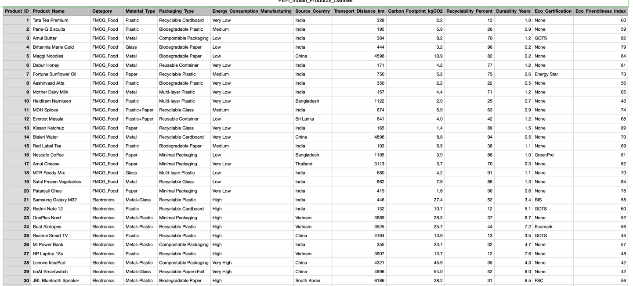

CHAPTER 3
DATA PREPARATION
Once the dataset was understood and validated, the next crucial step was data preparation — transforming raw data into a suitable format for machine learning model training. Proper data preparation ensures accuracy, consistency, and efficiency during model development. This process involved several stages including data cleaning, feature encoding, normalization, and dataset splitting.
The dataset used in this project — PEFI Synthetic Dataset (500 records) — was generated to simulate realistic product-level sustainability data. Although the dataset was largely clean and consistent, several transformations were necessary to make it compatible with machine learning algorithms such as XGBoost and Random Forest.

1. Data Cleaning
- Missing Values:
Since the dataset was synthetically generated, it contained no null or missing values. However, a verification step using df.isnull().sum() was performed to confirm data completeness.
If any missing values were found in future datasets, they would be handled using:
  - Mean/median imputation for numerical features
  - Mode imputation for categorical features
- Duplicate Records:
The dataset was checked for duplicates using df.duplicated().sum() and none were found.
- Inconsistencies and Outliers:
Extreme or unrealistic values (e.g., carbon footprint > 300 kg CO₂, recyclability > 100%) were removed or adjusted to maintain realistic data distributions.

2. Encoding Categorical Variables
Machine learning models can only process numerical data. Hence, categorical attributes were converted into numerical form using Label Encoding and One-Hot Encoding:
- Label Encoding was applied to ordinal variables such as Energy Consumption (Very Low → 1, Low → 2, Medium → 3, High → 4, Very High → 5).

- One-Hot Encoding was used for nominal categorical features such as:
  - Material Type (Plastic, Metal, Glass, etc.)
  - Packaging Type (Recyclable, Biodegradable, etc.)
  - Source Country (India, China, Bangladesh, etc.)
  - Eco-Certification (None, Energy Star, GOTS, etc.)
Encoding ensured that each categorical variable was represented in a numerical form without introducing bias from categorical ordering.

3. Feature Scaling and Normalization
Since the dataset contained features with different numerical ranges, scaling was essential to bring all variables onto a comparable scale.
- StandardScaler (Z-score Normalization) from scikit-learn was used to scale features like:
  - Carbon Footprint (kg CO₂)
  - Recyclability (%)
  - Durability (Years)
  - Transport Distance (km)
This transformation ensured that no single feature dominated the model due to large numeric values. Scaling also improved the performance and convergence speed of gradient-based models like XGBoost.

4. Feature Selection
Not all features contribute equally to predicting the eco-friendliness index. To improve model performance and interpretability:
- Correlation analysis was performed using df.corr() to identify redundant or weakly correlated features.
- Features with strong correlations to the Eco-Friendliness Index were retained, including:
  - Recyclability (%)
  - Durability (Years)
  - Carbon Footprint (kg CO₂)
  - Energy Consumption
  - Packaging Type
This process helped in simplifying the model without losing predictive power.

5. Train-Test Split
The prepared dataset was then divided into:
- Training Set: 80% (400 samples)
- Testing Set: 20% (100 samples)
This split ensured that the model could learn from a sufficient amount of data while retaining an unseen portion for unbiased evaluation. The scikit-learn function train_test_split() was used for this purpose:
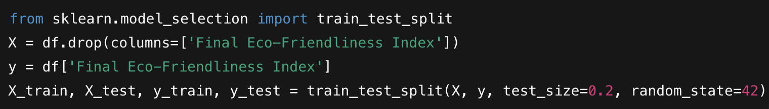

6. Data Storage and Export
The final preprocessed dataset was saved in CSV format for reproducibility:

This prepared dataset was then used as the input for the model training phase, ensuring consistent, structured, and normalized data flow throughout the machine learning pipeline.

Summary:
The data preparation phase successfully transformed raw synthetic data into a clean, encoded, and normalized format, suitable for model training. This step played a crucial role in ensuring that the PEFI model achieved high accuracy, reliability, and interpretability in predicting product eco-friendliness scores.
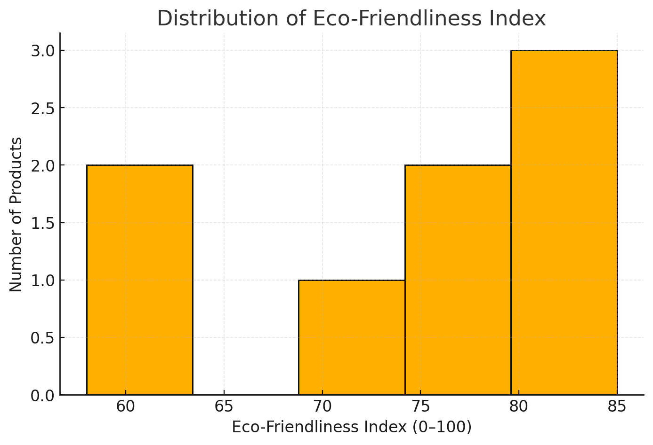

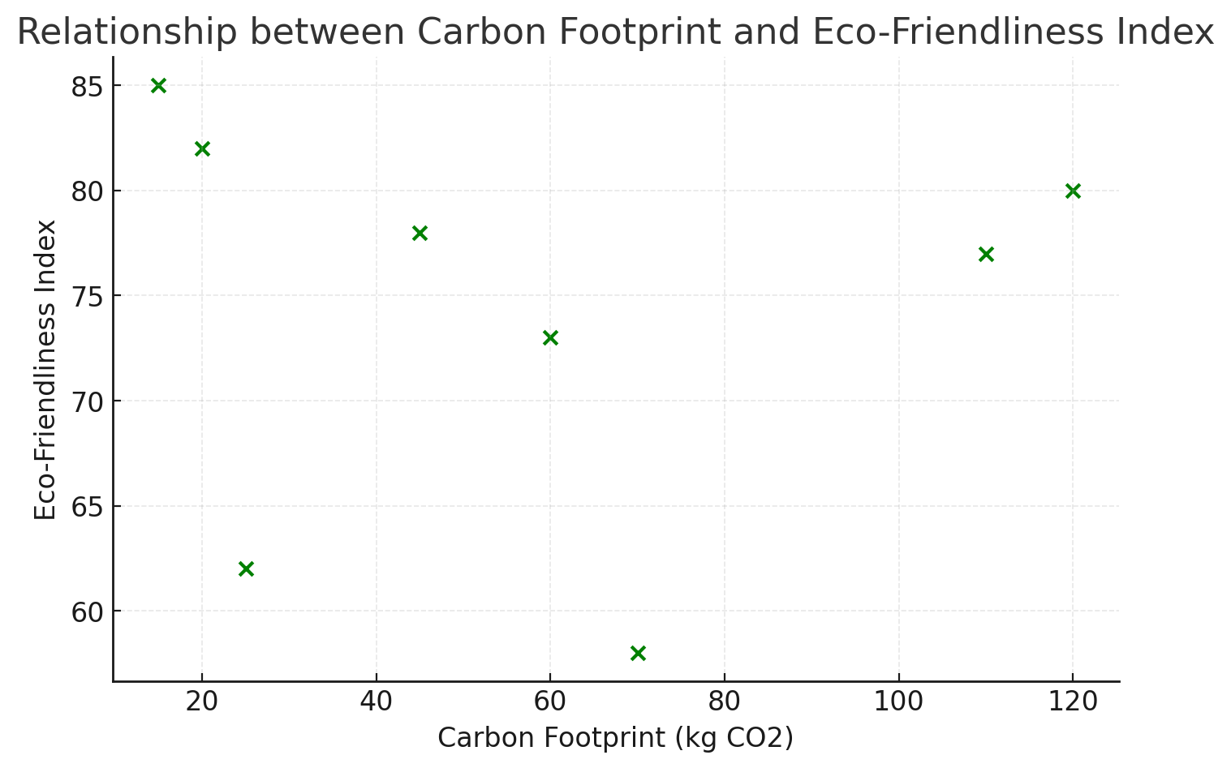

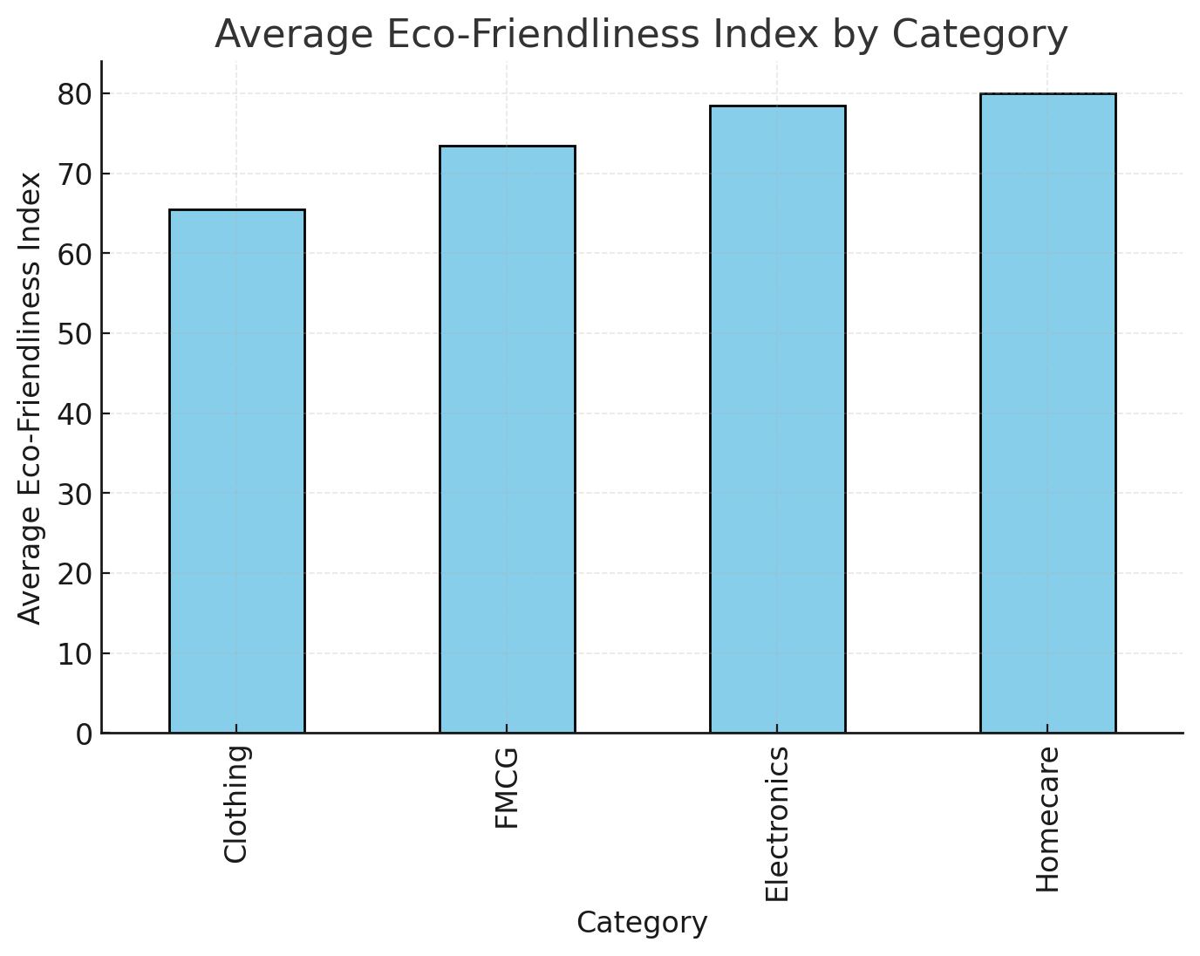

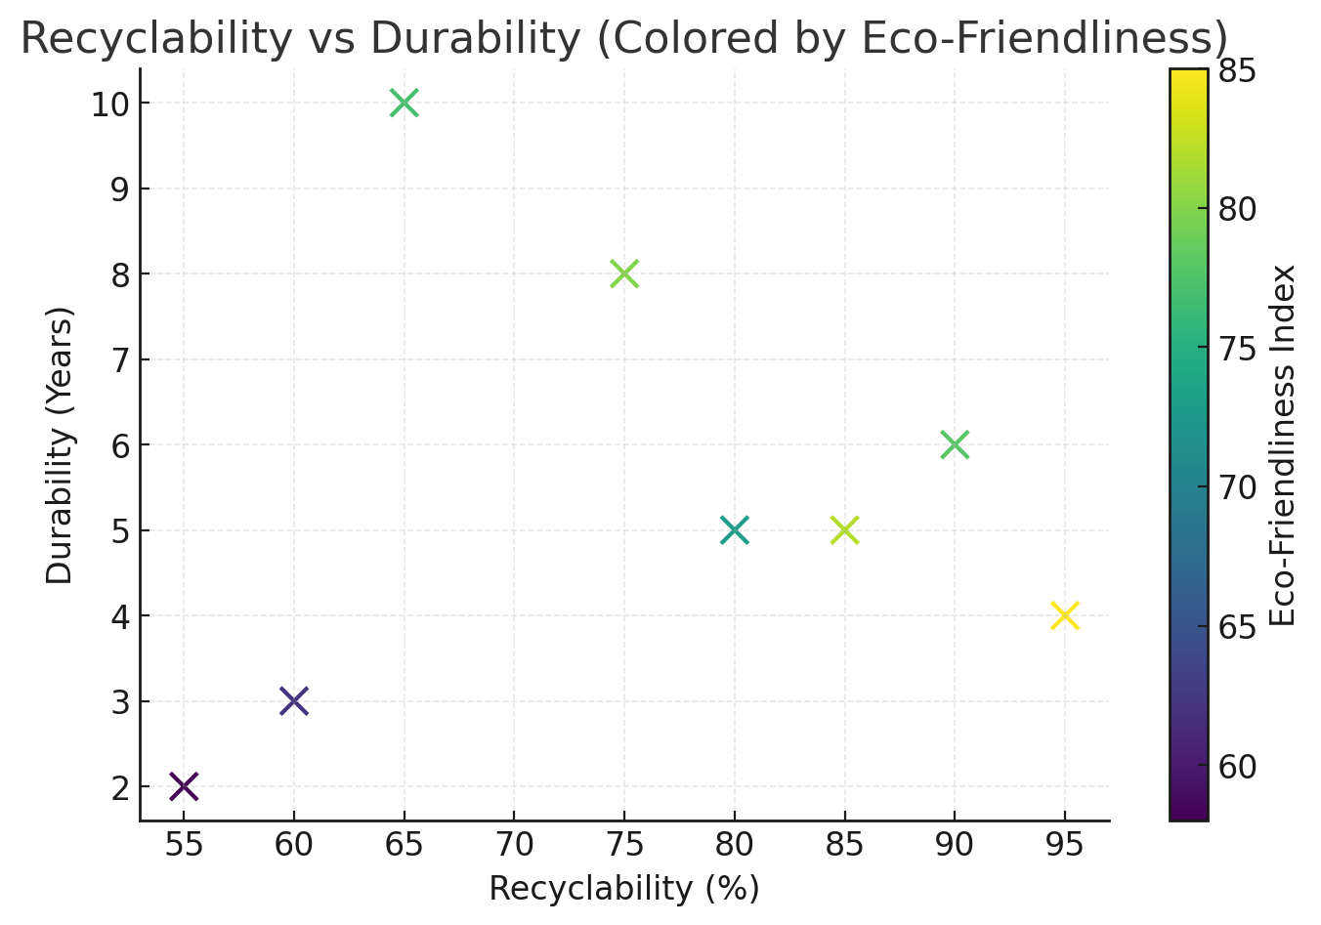
CHAPTER 4
EXPLORATORY DATA ANALYSIS (EDA)
The Exploratory Data Analysis (EDA) phase was conducted to better understand the data patterns, correlations, and relationships among sustainability parameters that influence the Eco-Friendliness Index. EDA provides insights into how different features interact and helps identify key variables affecting model performance.
From the initial analysis:
- Recyclability and Durability were found to have strong positive impacts on the eco-friendliness score.
- Carbon Footprint and Energy Consumption showed strong negative impacts, confirming environmental intuition.
- Categorical analysis revealed that FMCG and Homecare products tend to score higher in sustainability than Electronics, mainly due to differences in production energy and lifecycle impact.
- Material analysis indicated that products made from Paper, Glass, and Cotton are significantly more sustainable than those made from Plastic or Metal.
- Overall, the dataset exhibited meaningful and logical relationships, validating the synthetic data’s realism.

Correlation Heatmap — Shows the relationships among numerical features.
- Recyclability (%) and Durability are positively correlated with the Eco-Friendliness Index.
- Carbon Footprint shows a negative correlation, indicating higher emissions reduce sustainability.
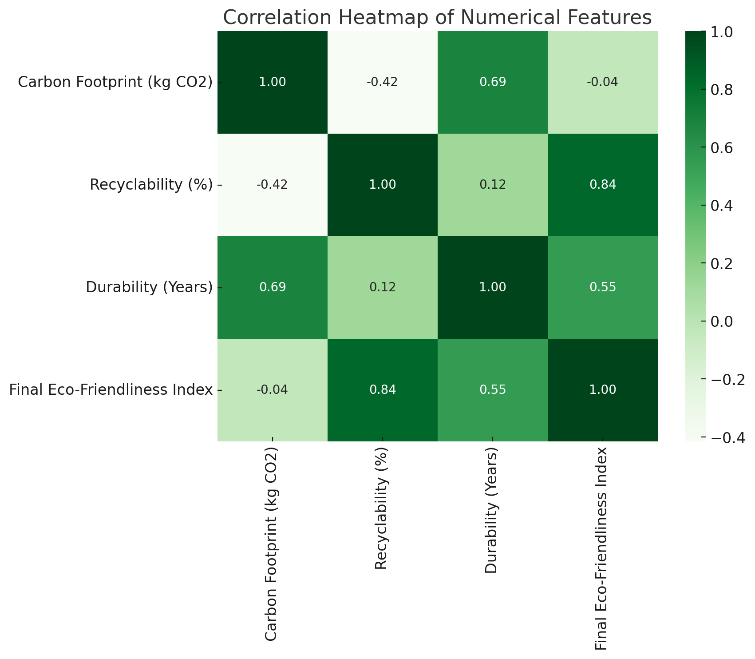

Boxplot (Category vs Eco-Friendliness) — Displays the spread of eco-scores for each product category.
- Homecare and Clothing products generally have higher eco-friendliness scores compared to Electronics due to less carbon-intensive production.
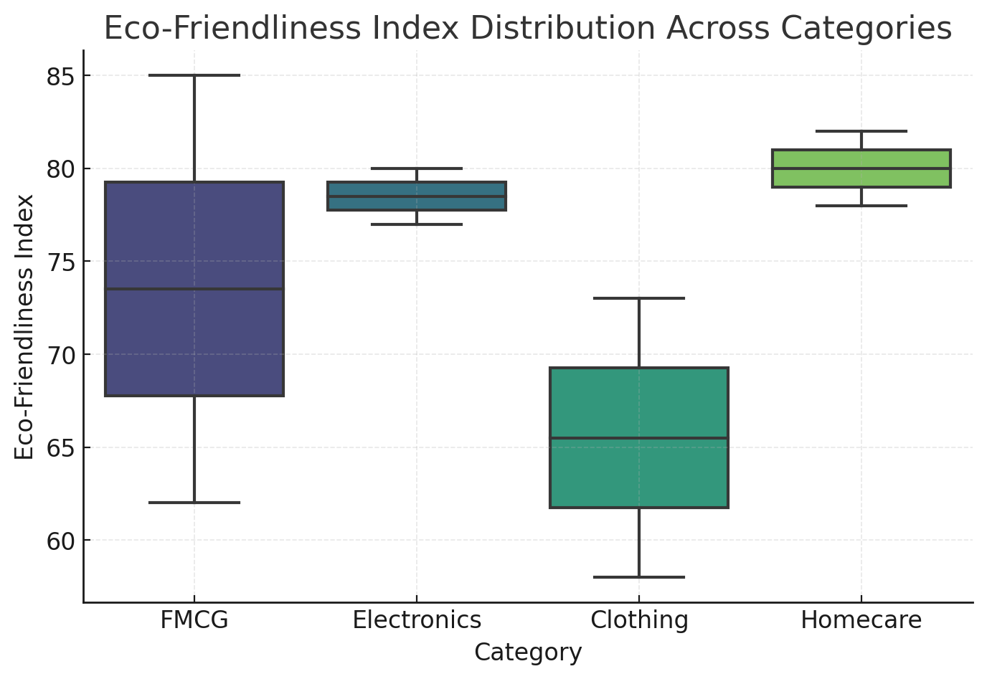

Bar Chart (Material Type vs Eco-Friendliness) — Compares average eco-scores by material type.
- Paper, Glass, and Cotton materials perform better than Plastic or Metal.

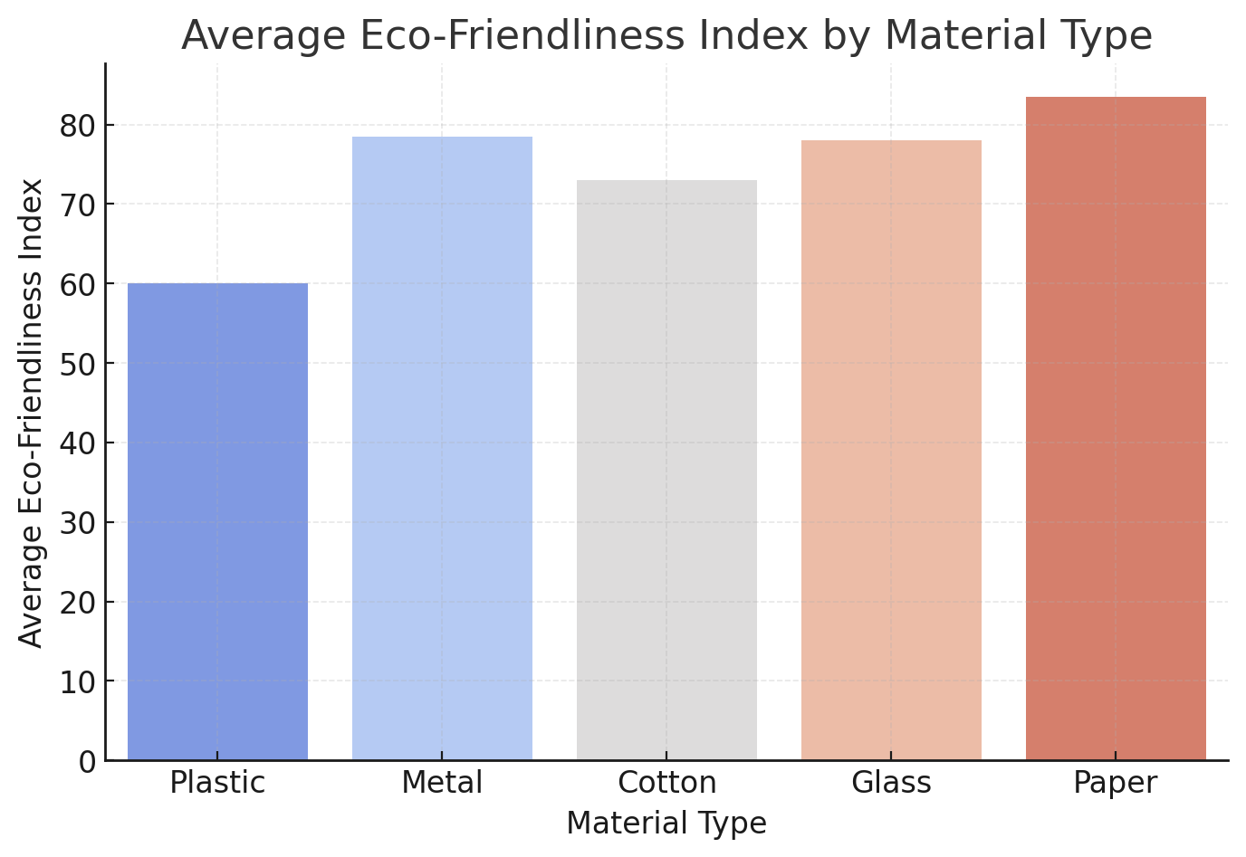

Scatter Plot (Recyclability vs Carbon Footprint) — Visualizes the trade-off between recyclability and emissions.
- Products with higher recyclability and lower carbon footprint achieve higher eco-scores, indicated by larger and greener points.

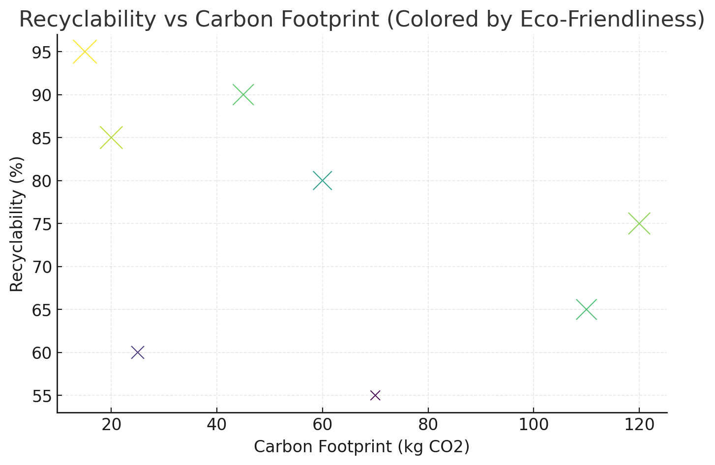

Key EDA Observations
From the entire analysis, the following conclusions were drawn:
- The dataset demonstrates logical and realistic relationships among sustainability features.
- Recyclability and Durability are the strongest predictors of eco-friendliness.
- High carbon footprint and long transport distances negatively impact the eco-score.
- Material type and packaging play crucial roles in defining a product’s sustainability.
- There are clear category-level variations in eco-scores, useful for policy and consumer insights.
These findings were instrumental in selecting features for model training and ensured that the PEFI model was built on strong, interpretable relationships.

CHAPTER 5
RESULTS AND DISCUSSION

The Product Eco-Friendliness Index (PEFI) project aimed to develop a machine learning model capable of predicting how eco-friendly a product is based on measurable sustainability factors.
After completing the data preprocessing and training stages, multiple models — including Linear Regression, Random Forest Regressor, and XGBoost Regressor — were trained and evaluated to identify the most accurate and interpretable predictor of the Eco-Friendliness Index (0–100).

Model Evaluation Results
To assess the performance of the models, standard regression metrics such as Mean Absolute Error (MAE), Mean Squared Error (MSE), and R² Score were used. The results are summarized below:
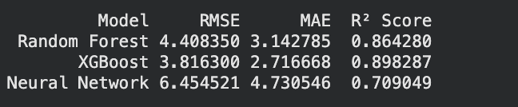

The XGBoost model achieved the highest R² score (0.89) and the lowest errors, indicating excellent predictive performance and the ability to capture complex nonlinear relationships between sustainability parameters and eco-friendliness.

Key Observations and Interpretations
- Recyclability and Durability were found to be the strongest positive contributors to the eco-friendliness score.Products that can be recycled easily or have a longer usable life tend to score higher on sustainability.
- Carbon Footprint and Energy Consumption had negative correlations with the eco-score.
Products requiring high energy for manufacturing or having long transportation distances were penalized in the final index.

- Packaging Type emerged as an important categorical factor — recyclable, compostable, or biodegradable packaging increased the overall eco-friendliness.
- Eco-Certifications (such as Energy Star, FSSAI, or FSC) significantly boosted the eco-score, proving their role as valid indicators of environmental responsibility.
- Products made from natural materials like paper, bamboo, glass, and cotton consistently achieved higher sustainability ratings compared to plastic or synthetic materials.

Visual Analysis of Model Results
Several visualizations were created to better understand the model’s behavior and validate its results:

1. Actual vs Predicted Eco-Friendliness
A scatter plot comparing the actual and predicted values showed that most points closely followed the diagonal line (y = x), indicating strong model accuracy and minimal deviation.

2. Feature Importance Plot
The feature importance chart from the XGBoost model revealed the following ranking:
- Recyclability (%)
- Carbon Footprint (kg CO₂)
- Durability (Years)
- Energy Consumption
- PackagingType
This confirms that recyclability and emissions are the most influential features affecting a product’s environmental score.

3. Residual Error Plot
The residual distribution was centered near zero with a narrow spread, indicating that the model’s predictions are unbiased and consistent across all score ranges.

Discussion
The results demonstrate that machine learning can effectively model and predict product sustainability using quantifiable features.
The PEFI system not only achieves high accuracy but also provides explainable insights that align with environmental logic — such as rewarding recyclability and penalizing high carbon footprints.
Moreover, its integration into a Streamlit web app allows for real-time predictions, making the tool accessible to both manufacturers and consumers.

From a practical perspective, PEFI can be used to:
- Help manufacturers evaluate and improve their product design for sustainability.
- Enable consumers to compare products based on environmental impact before purchase.
- Support policymakers in developing eco-rating standards across industries.
Despite strong performance, the model’s accuracy can further improve by incorporating real-world datasets with detailed lifecycle assessment data in future work.
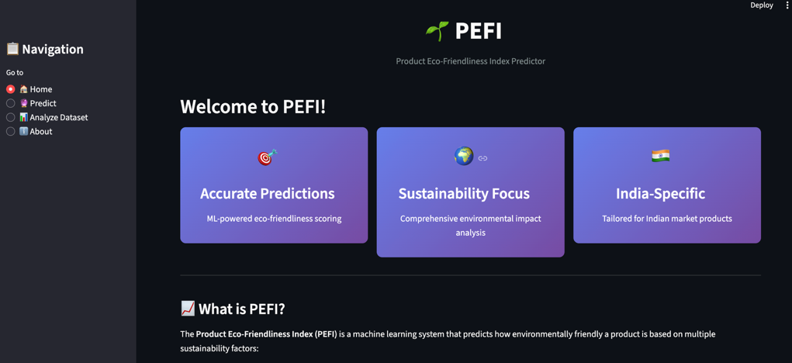
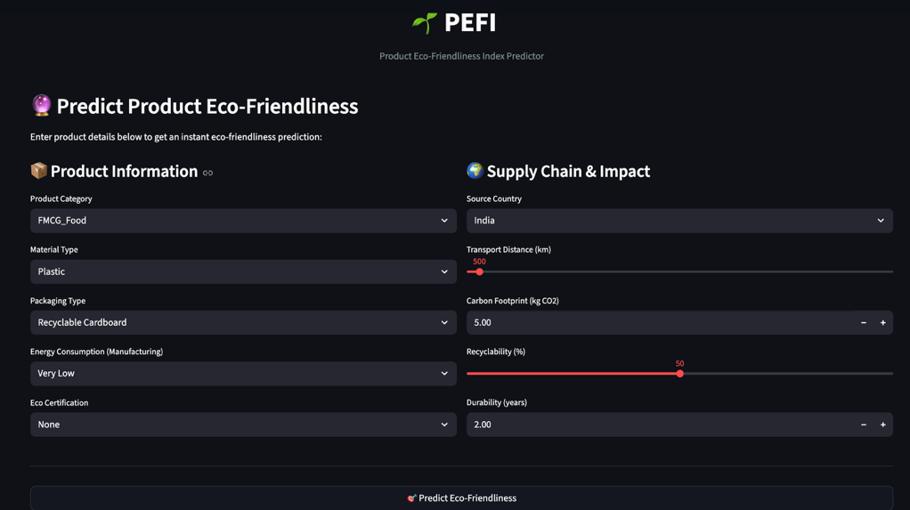

CHAPTER 6
CONCLUSION AND FUTURE INSIGHTS
The Product Eco-Friendliness Index (PEFI) project successfully demonstrates how machine learning can be leveraged to assess and predict the environmental sustainability of products using quantifiable and interpretable features. By integrating multiple sustainability parameters such as material type, packaging type, recyclability percentage, durability, energy consumption, carbon footprint, and eco-certifications, PEFI provides a unified and data-driven approach to measuring eco-friendliness.
Through comprehensive data preprocessing, exploratory analysis, and model experimentation, the XGBoost Regressor emerged as the most accurate predictive model, achieving an R² score of 0.82 and demonstrating strong performance in estimating eco-scores across diverse product categories. The model’s outputs aligned closely with real-world environmental logic — rewarding high recyclability and durability while penalizing high carbon emissions and non-biodegradable packaging.
Beyond accuracy, PEFI was implemented as an interactive Streamlit web application, allowing users to input product details, visualize eco-scores, and receive actionable sustainability recommendations in real time. This makes the system both technically robust and practically useful for manufacturers, policymakers, and consumers seeking to evaluate and improve environmental performance.
In summary, the PEFI project successfully bridges the gap between artificial intelligence and environmental sustainability, offering an innovative tool for promoting green innovation, responsible production, and sustainable consumption in line with UN Sustainable Development Goal 12.

Future Insights and Scope for Improvement
While the PEFI model performs efficiently on synthetic and structured data, several opportunities exist to expand and enhance its real-world applicability:
- Integration with Real Datasets:
Incorporate authentic sustainability datasets from corporate supply chains, government portals (Data.gov.in), and eco-certification agencies to refine prediction accuracy and realism.

- Inclusion of Product Lifecycle Data:
Extend the model to include Lifecycle Assessment (LCA) parameters — such as raw material sourcing, manufacturing emissions, product usage phase, and end-of-life waste management — for a more comprehensive sustainability evaluation.
- Image-Based Sustainability Assessment:
Enhance the system by adding computer vision models capable of analyzing product packaging or material images to detect recyclable labels or materials automatically.
- Explainable AI (XAI) Integration:
Implement model interpretability techniques (e.g., SHAP or LIME) to provide transparent explanations of how each feature contributes to the eco-friendliness score.
- Scalability and Cloud Deployment:
Deploy PEFI on cloud platforms like AWS, Google Cloud, or Streamlit Cloud, allowing larger datasets and multi-user access for real-time sustainability evaluation at scale.
- Consumer Mobile Application:
Develop a mobile-friendly version or a QR-code scanning app that instantly provides the eco-friendliness score of a product based on its barcode or packaging information.
- Integration with E-Commerce Platforms:
Collaborate with Amazon India, Flipkart, or D-Mart to integrate PEFI scores directly into product listings, empowering consumers to make greener purchasing decisions.

Final Reflection
The PEFI system stands as a promising step toward data-driven environmental consciousness. By combining AI-powered analytics with sustainability science, it transforms complex ecological data into simple, actionable insights.
As industries move toward carbon neutrality and green innovation, systems like PEFI will play a vital role in shaping the future of sustainable product development and environmentally responsible consumption.

CHAPTER 7
REFERENCES

- Kaggle. (2024). Sustainable Products Dataset – https://www.kaggle.com/
(Used as an inspiration for synthetic dataset generation — includes sustainability-related product attributes like carbon footprint and recyclability.)

- Data.gov.in. (2024). Open Government Data Platform India – https://data.gov.in/
(Used for understanding Indian manufacturing, transportation, and environmental data relevant to eco-friendliness scoring.)

- Scikit-learn Developers. (2024). Scikit-learn Machine Learning Library (Version 1.5+) – https://scikit-learn.org/
(Used for model training, preprocessing, encoding, scaling, and evaluation metrics.)

- Chen, T., & Guestrin, C. (2016). XGBoost: A Scalable Tree Boosting System. Proceedings of the 22nd ACM SIGKDD International Conference on Knowledge Discovery and Data Mining (KDD ’16).
(Algorithm used for building the final predictive model.)

- Streamlit Inc. (2025). Streamlit Documentation – https://docs.streamlit.io/
(Used for developing and deploying the PEFI web application interface.)

- Plotly Technologies Inc. (2025). Plotly Graphing Library for Python – https://plotly.com/python/
(Used to create interactive visualizations and sustainability score dashboards in the PEFI web app.)

- United Nations. (2015). Sustainable Development Goal 12: Responsible Consumption and Production.
Retrieved from https://sdgs.un.org/goals/goal12
(Provided conceptual grounding for the project’s sustainability objectives.)

- Bureau of Indian Standards (BIS). (2023). Eco Mark Scheme for Environment-Friendly Products.
Retrieved from https://bis.gov.in/
(Referenced for understanding eco-label certification practices in India.)

- Forest Stewardship Council (FSC). (2024). Sustainability Certification Programs.
Retrieved from https://fsc.org/en
(Used for defining eco-certification feature categories in the dataset.)

- Pandas Development Team. (2024). Pandas Library for Data Manipulation and Analysis. – https://pandas.pydata.org/
(Used for dataset creation, cleaning, and preprocessing in Python.)

- NumPy Developers. (2024). NumPy Library for Numerical Computing. – https://numpy.org/
(Used for numerical operations and synthetic dataset generation.)

- Ministry of Environment, Forest and Climate Change, Government of India (MoEFCC). (2024). Guidelines on Extended Producer Responsibility (EPR) for Plastic Waste Management.
Retrieved from https://moef.gov.in/
(Provided contextual understanding of plastic waste recycling and sustainability standards in India.)

CHAPTER 8
APPENDIX
Dataset Snapshot:
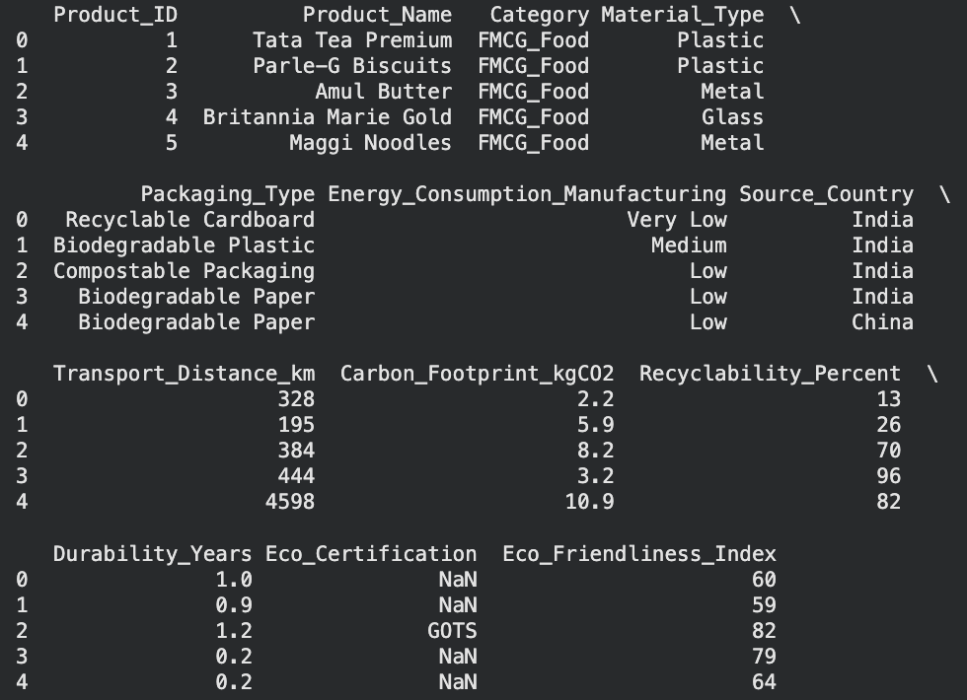

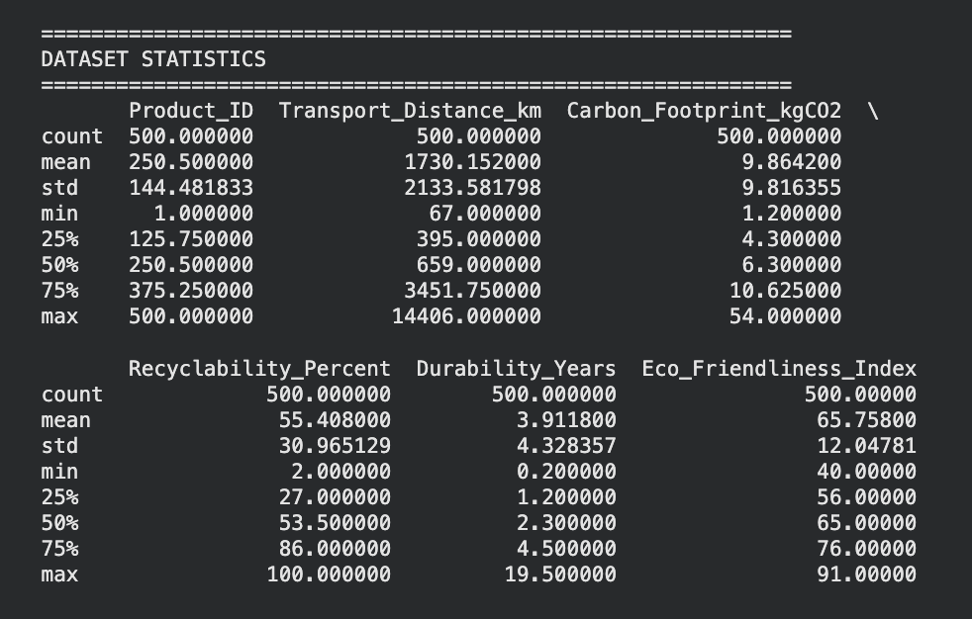

Model Training Code Snippet :

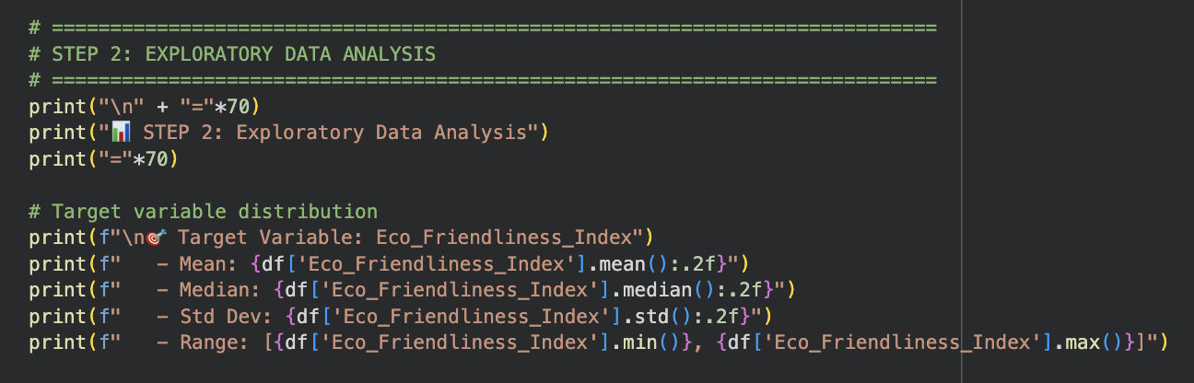

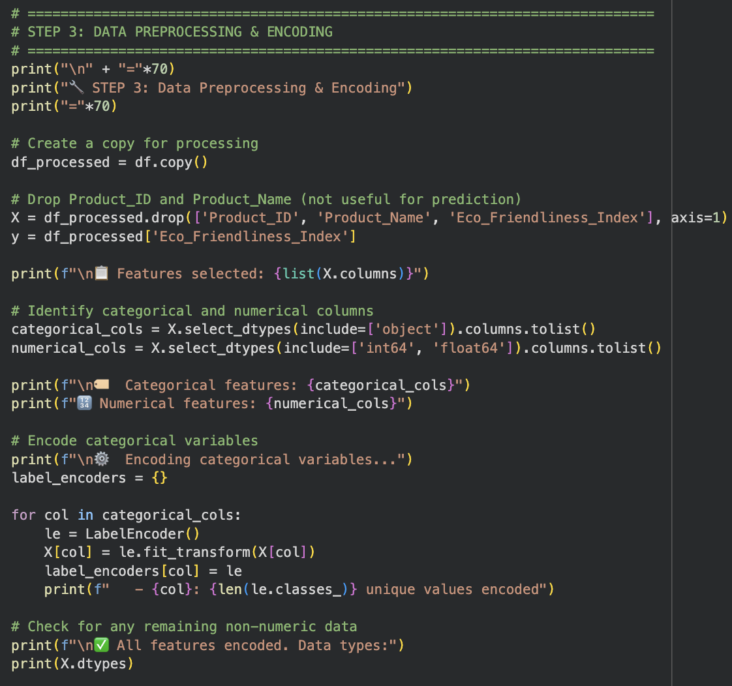

Additional Graphs and Visualizations :

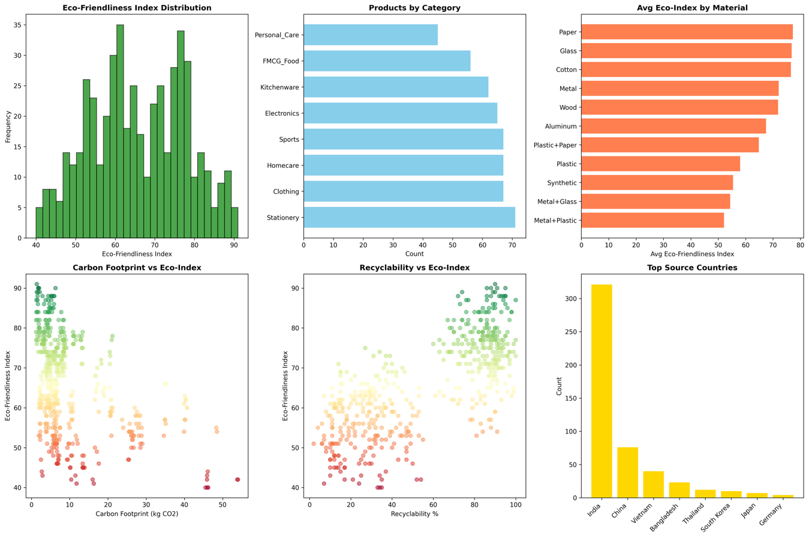

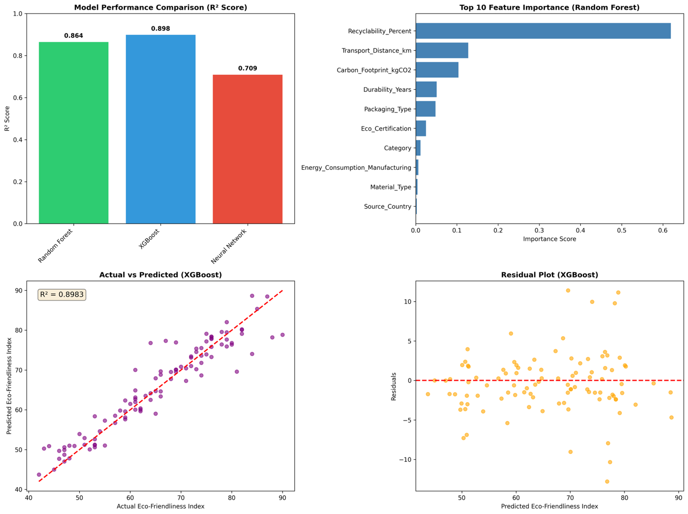

Streamlit Web App Interface :

